Financial Quotes of the Day or Week or Month or Whenever

Place them on your emails, website, social media

It is fun and a GREAT way to participate in The Improving Financial Awareness & Financial Literacy Movement. You can use them to celebrate

- April as Financial Literacy Month
- October as Estate and Gift Planning Awareness Month
- or any time of the year!!!

To learn more about The Movement, and become a TFAF Strategic Partner, Ambassador, or Volunteer

- http://www.thefinancialawarenessfoundation.org/pdf/TFAF-TIFA-FLMovement-Ghana-ExecSum.pdf

- http://www.thefinancialawarenessfoundation.org/pdf/TFAF-Africa-TIFA-FLM.pdf

- http://www.thefinancialawarenessfoundation.org/pdf/TFAF-Ghana-JoinTheMovement-PersonalFinKnowledge.pdf

- https://home.thefinancialawarenessfoundation.org/pdf/TheMovementWorldWide.pdf

On the following pages, see what others are doing and Templates and samples you can use, or design the perfect one of your own!!! Following an initial collection of financial quotes for your use, or you can create or find you own; or if you need more let us know.

Look what The FA Association at the University of Ghana are doing with their Daily Financial Quotes!!!

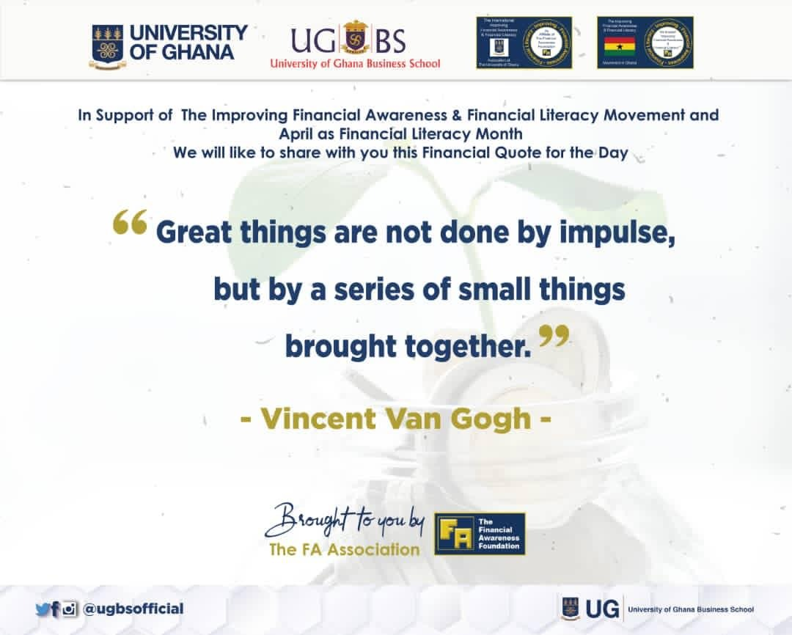

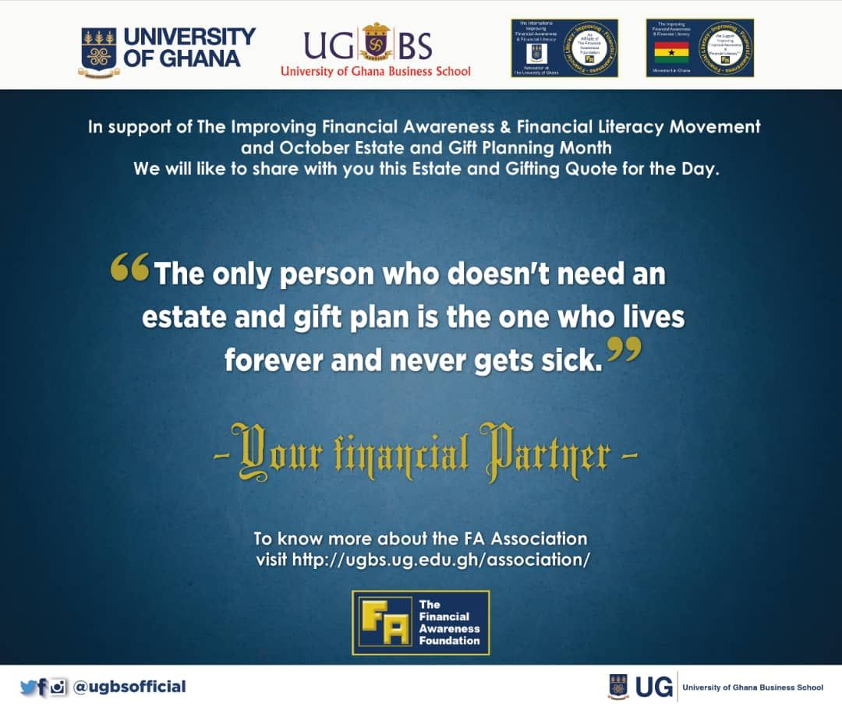
You can use the following as a template; just
- Replace the text box below with a nice graphic of your logo
- Add you URL below
- Capture this as a PDF, PNG or JPEG; if you use the PDF you can imbed links on it!!!
- or export this page as a PDF, then save the PDF as an Image / PNG or JPEG
- Circulate in your Social Media and Emails
- Repeat it - with a new Financial Quote from the list the follows, or
- Create your own template and use the financial quotes or find or create your own.
****
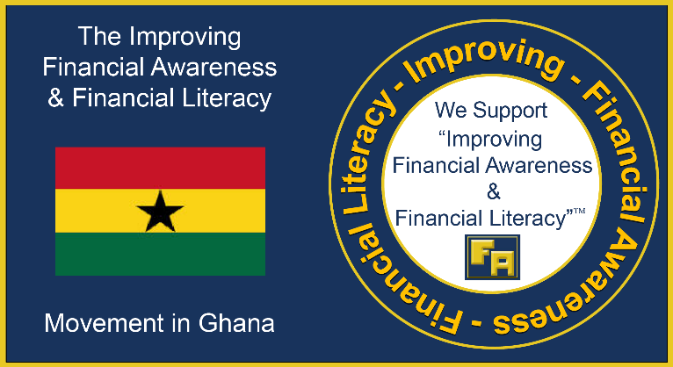
In Support of
The Improving Financial Awareness &
Financial Literacy Movement
October as
Estate & Gift Planning Awareness Month
We are sharing with you this Financial Quote for the Day

“The only person who doesn't need an estate and gift plan is the one who lives forever and never gets sick.”
-Your financial PARTNER
www.xxxx.com Your URL
http://www.thefinancialawarenessfoundation.org/pdf/TFAF-TIFA-FLMovement-Ghana-ExecSum.pdf
Replace this text box
with your logo
http://www.thefinancialawarenessfoundation.org/pdf/TFAF-Ghana-JoinTheMovement-PersonalFinKnowledge.pdf
***
Happy Financial Literacy Month

In Support of
The Improving Financial Awareness &
Financial Literacy Movement, celebrating
April as Financial Literacy Month, we are sharing this Financial Quote with you!
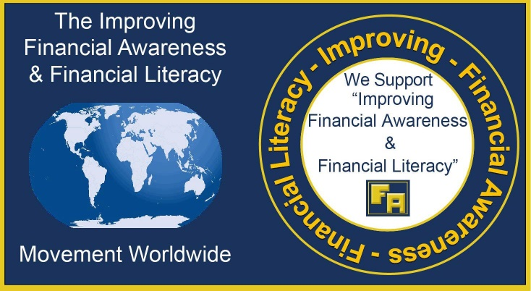

https://home.thefinancialawarenessfoundation.org/pdf/TheMovementWorldWide.pdf

"I long to accomplish a great and noble task; but it is my chief duty and joy to accomplish humble tasks as though they were great and noble. The world is moved along, not only by the mighty shoves of its heroes, but also by the aggregate of the tiny pushes of each honest worker." — Helen Keller

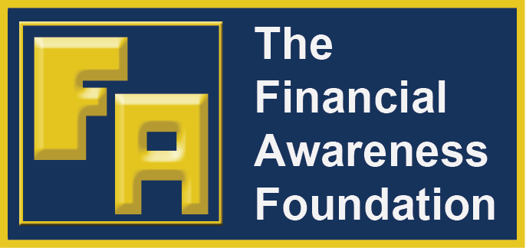

http://www.thefinancialawarenessfoundation.org/

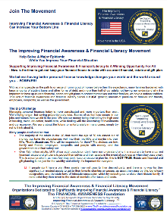
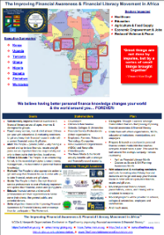
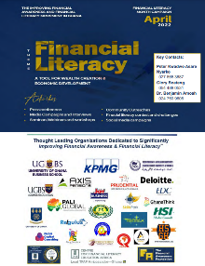
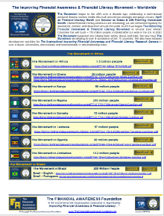
Join The Movement - help make this a better world for all!
Click on the graphics to see what others are doing

***

***

In Support of
The Improving Financial Awareness &
Financial Literacy Movement
and April known as
Financial Literacy Month
We are sharing with your this Financial Quote for the Day
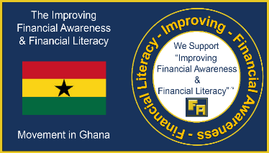
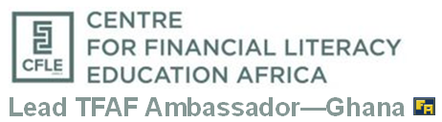

A giving life is a great life. The act of giving is a great way to touch and impact millions. —Peter Kwadwo Asare Nyarko

https://cfleafrica.org/
http://www.thefinancialawarenessfoundation.org/pdf/TFAF-TIFA-FLMovement-Ghana-ExecSum.pdf
***

***
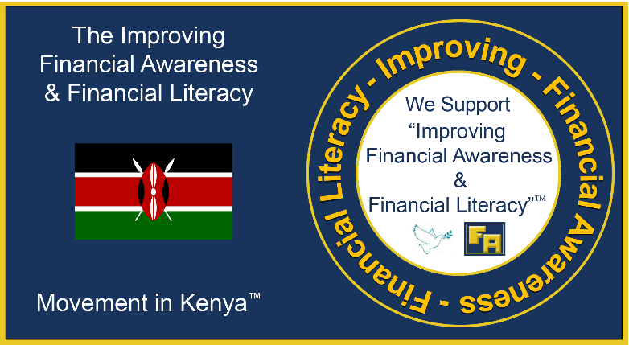
In Support of
The Improving Financial Awareness &
Financial Literacy Movement
In Kenya
We are sharing with your this Financial Quote for the Week

“Improving Financial Awareness & Financial Literacy changes your world and the world around you… FOREVER!” – Michael Ochieng Nyawino
https://cohecfkenya.org/
http://www.thefinancialawarenessfoundation.org/pdf/TFAF-TIFA-FLMovement-Kenya-ExecSum.pdf
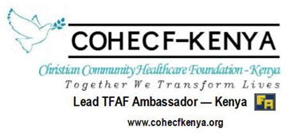
***

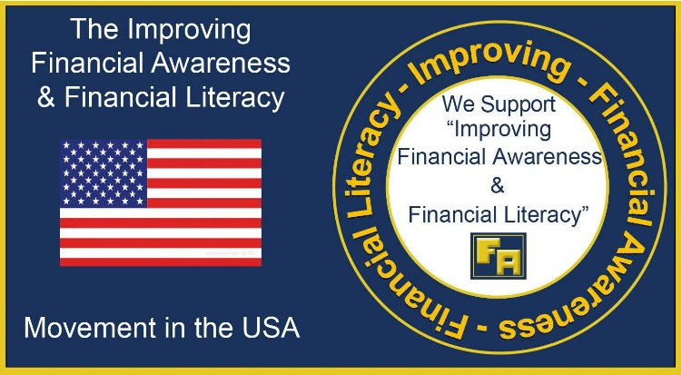
In Support of
The Improving Financial Awareness &
Financial Literacy Movement
and April as
Financial Literacy Month
We are sharing with your this Financial Quote for the Day
https://www.mindmoneymotion.com/
http://www.thefinancialawarenessfoundation.org/pdf/TFAF-FallCampaignReport&Magazine.pdf
“Financial Literacy: The understanding and the effective use of a set of skills and knowledge - the essential principles to smart money management, the foundation to personal finance knowledge - that allows you to address everyday money decisions in an informed manner.” – TFAF

Financial Quotes for the Day

Financial Awareness Estate & Gift Planning Awareness

 |  | “Financial Literacy: The understanding and the effective use of a set of skills and knowledge - the essential principles to smart money management, the foundation to personal finance knowledge - that allows you to address everyday money decisions in an informed manner.” – TFAF |  | “The only person who doesn't need an estate and gift plan is the one who lives forever and never gets sick.” - -Your financial PARTNER
 |  | “Great things are not done by impulse, but by a series of small things brought together.” - Vincent Van Gogh |  | A giving life is a great life. The act of giving is a great way to touch and impact millions.  —Peter Kwadwo Asare Nyarko
 |  | Early in my career I felt that organization would destroy my creativity. Whereas now, I feel the opposite. Discipline is the concrete that allows me to be creative.” - Verna Gibson |  | Your Personal Financial Plan is not complete without and Estate and Gift Plan. – The FA Association
 |  | “The single biggest difference between financial success and financial failure is how well you manage your money. It’s simple: to master money, you must manage money” T. Harv Eker, |  | Wills are trumped by legal titles to real estate or beneficiary designations on financial accounts, retirement plans and insurance policies. - Jean Chatzky
 |  | “Whiles you may not have all the money to put your mind at ease, financial planning helps you confront the essentials of your financial being.”- Benjamin Amoah |  | A misconception about estate planning is it only benefits the super wealthy! This is not true! If you own property and assets, or have loved ones that depend on you, then you have an estate and you need a plan.- The FA Association.
 |  | “If you don’t understand the language of money you’re just an economic slave.” |  | Before you speak, listen. Before you write, think. Before you spend, earn. Before you invest, investigate. Before you criticize, wait. Before you pray, forgive. Before you quit, try. Before you retire, save. Before you die, give. - William A. Ward
 |  | “Those who master money are free to serve others still mastered by it.” Orrin Woodward |  | “If you think you're too small to have an impact, try going to bed with a mosquito in the room.” —Anita Roddick
 |  | “Financial health is a privilege that should be afforded to everyone – and it starts with being willing to have the conversation while also recognizing our own background and bias.” – Erin Lowry |  | Estate and gift planning are not only for the wealthy. Everybody can benefit from ensuring their assets and finances are properly taken care of after their death. - Lee Mezrah and Leon Mezrah
 |  | “A person either disciplines his finances or his finances disciplines him.” Orrin Woodward |  | Estate planning allows you the ability to name your children’s guardian in the event of your premature death. - Donna Fuscaldo
 |  | “A financial dream isn’t a financial goal. A financial dream is something you hope for. A financial goal is something you have planned for.”– Peter Kwadjo Asare Nyarko. |  | "Procrastination gives you something to look forward to." - Joan Konner
 |  | “If the notion of personal finance education puts fear in you, then you are most likely not practicing personal finance.” -Benjamin Amoah |  | Giving is a great way to reach out and help others, plan giving and being intentional about who you give to, and what course you give to is even more impactful. —Peter Kwadwo Asare Nyarko
 |  | “I never want money to dictate what I can and can’t do in life.” Jessica Moorhouse |  | Decide and document rightfully while you can, who takes charge of your legacies before leaving earth. Make a WILL!  —Peter Kwadwo Asare Nyarko
 |  | “I believe that through knowledge and discipline, financial peace is possible for all of us.” - Dave Ramsey |  | Estate planning minimizes the chances of family strife and ugly legal battles. .- Donna Fuscaldo
 |  | “No one’s ever achieved financial fitness with a January resolution that’s abandoned by February.” |  | It requires a great deal of boldness and a great deal of caution to make a great fortune, and when you have it, it requires ten times as much skill to keep it. - Ralph Waldo Emerson
 |  | “Organizing is what you do before you do something, so that when you do it, it is not all mixed up.” –A. Milne |  | If you want to choose who will inherit what among your possessions and valuables, you need do some estate planning.- Donna Fuscaldo
 |  | “When you have money, think of the time when you had none.” - Japanese Proverb |  | Life is made of millions of moments, but we live only one of these moments at a time. As we begin to change this moment, we begin to change our lives. - Trinidad Hunt
 |  | “Creditors have better memories than debtors.” - Benjamin Franklin |  | There's nothing fun about stuff like estate planning, getting mammograms, or talking to a guy about long term disability insurance, but do it anyway. Trust me, the stress of not having done the above is prematurely aging. - Jen Lancaster
 |  | “The philosophy of the rich and the poor is this: the rich invest their money and spend what is left. The poor spend their money and invest what is left.” - Anon |  | Death and taxes may be inevitable, but they shouldn't be related. ~J.C. Watts, Jr.
 |  | “To acquire money requires valor, to keep money requires prudence, and to spend money well is an art.” - Berthold Auerbach |  | Death comes equally to us all, and makes us all equal when it comes. - John Donne
 |  | “Wealth is not about having a lot of money; it’s about having a lot of options.” - Chris Rock |  | Fear not that thy life shall come to an end, but rather fear that it shall never have a beginning. - John Henry Cardinal
 |  | “You must gain control over your money or the lack of it will forever control you.” -Dave Ramsey |  | It's important to have a solid estate plan in place to ensure that your loved ones receive your assets without a hassle or undue delay after your death. - Donna Fuscaldo
 |  | “A budget is telling your money where to go instead of wondering where it went.” ― Dave Ramsey |  | No matter how rich you become, how famous or powerful, when you die the size of your funeral will still pretty much depend on the weather. - Michael Pritchard
 |  | “Money is only a tool. It will take you wherever you wish, but it will not replace you as the driver.” — Ayn Rand |  | Estate planning shouldn’t solely be viewed as preparations for after you are deceased, it’s also about planning for incapacity during your lifetime. Health emergency or accidents can happen to anyone at any time. – Cap Fed
 |  | “A budget is more than just a series of numbers on a page; it is an embodiment of our values.” ― Barack Obama |  | God put me on the earth to accomplish a certain number of things, right now I am so far behind that I’ll never die. - unknown
 |  | “There is a gigantic difference between earning a great deal of money and being rich.”— Marlene Dietrich |  | "Once the game is over, the king and pawn go back into the same box." --- Italian proverb
 |  | “Money is a guarantee that we may have what we want in the future. Though we need nothing at the moment it insures the possibility of satisfying a new desire (need) when it arises.”— Aristotle |  | Money doesn't talk, it swears. ~Bob Dylan
 |  | “Beware of little expenses; a small leak can sink a great ship.” - Benjamin Franklin |  | If you think nobody cares if you're alive, try missing a couple of car payments. ~Earl Wilson
 |  | “The puzzle in retirement planning; the young with little personal finance knowledge easily profess an enjoyable after-work life, while many near retirement decry the lack of personal finance knowledge in their youthful age. The solution - apply personal finance knowledge”.-Benjamin Amoah |  | At times our own light goes out and is rekindled by a spark from another person. Each of us has cause to think with deep gratitude of those who have lighted the flame within us. - Albert Schweitzer
 |  | “Use Warren Buffett’s 5 / 25 exercise to help get and keep focused. If you really want to get ahead and achieve your goals start by listing your 25 top goals. Then circle your top 5. Then commit only to these top 5 and TOTALLY ignore all the rest until you’ve accomplished the top 5.” - Warren Buffett |  | Estate planning should be looked at as part of life planning. – The FA Association
 |  | “The best money or financial advice is to educate yourself financially.” - Peter Kwadjo Asare Nyarko |  | None of us really like to think about our own mortality or the possibility of being unable to make decisions for ourselves. This is exactly why so many families are caught off-guard and unprepared when incapacity or death does strike. Don’t wait. You can put something in place now and change it later—which is exactly the way estate planning should be done. - Kelly Longtin
 |  | “Improving Financial Awareness & Financial Literacy changes your world and the world around you… FOREVER!” – Valentino Sabuco |  | The topic of end-of-life planning may seem depressing, but by being prepared you can save your family a lot of stress in the long run. – The Fa Association
 |  |  |  | Estate planning is an important and everlasting gift you can give your family. And setting up a smooth inheritance isn't as hard as you might think. - Suze Orman
 |  |  |  | Believe it or not, you have an estate. In fact, nearly everyone does. Your car, home, your, other real estate, checking and savings accounts, investments, life insurance, furniture, personal possessions such bags, shoes; adopt Estate Planning- The FA Association
 |  |  |  | Estate planning is one of the most thoughtful and considerate things you can do for your loved ones .- The FA Association
 |  |  |  | Would your family know where to find your financial records, titles, and insurance policies if something happened to you? Think Estate Planning – The FA Association
Estate planning involves determining how an individual’s assets will be preserved, managed, and distributed after death or in the event, they become incapacitated.
Life becomes more meaningful, humbling and impactful if one adopts Estate Planning- The FA Association.
 |  |  |  | Your parents planned your entry into this world, you have to plan your exit, estate and gift plan is the strategy to protect your love ones.- Benjamin Amoah
 |  |  |  | Do not forget to include in your Estate plans, gifts to your community, alma-malter, charities, church, the less privilege etc. -The FA Association

Here’s an interesting quote from John Legend presentation to Dukes graduating class

“Our nation is at its best when we realize that we all do better when we all do better. Yet, today, we’re still fighting against the old zero-sum thinking that’s been holding us back since the beginning.” – John Legend
https://today.duke.edu/2021/05/john-legend-leading-love-build-healthier-and-safer-communities
We see it around the world. In places like China, Hungary, Russia, India, Myanmar — across the globe, nativism, sectarianism, exploitation, and authoritarianism are gaining ground.
We see it in efforts to hoard economic opportunity, too. Today, the 26 wealthiest people on the planet own as much as the 3.5 billion poorest.
And powerful people are spending lots of money lobbying to keep it that way.
And, of course, we see it in our policing and carceral systems: In the simple fact that so many people heard “Black Lives Matter” and assumed it meant that other lives couldn’t matter, too. That’s zero-sum thinking if I’ve ever seen it.
Now, I know some of you may be thinking: “Why is he bringing us down on our graduation day?”
And you wouldn’t be the first to say something like that.
“As North Carolina native Nina Simone once said, ‘It is an artist’s duty to reflect the times in which we live.’ And you know what I think? It is also a banker’s duty. It’s a lawyer’s duty, a doctor’s duty, a teacher’s duty, an engineer’s duty, an entrepreneur’s duty, a plumber’s duty, a nurse’s duty. A mom’s and dad’s duty.”
I’ve been hearing calls to “shut up and sing” for my entire career. (Shut up and sing)
Well, as North Carolina native Nina Simone once said, “It is an artist’s duty to reflect the times in which we live.”
And you know what I think?
It is also a banker’s duty. It’s a lawyer’s duty, a doctor’s duty, a teacher’s duty, an engineer’s duty, an entrepreneur’s duty, a plumber’s duty, a nurse’s duty. A mom’s and dad’s duty.
Class of 2021, Duke has poured all kinds of tools and resources and experiences into you.
I am asking you today to use them on behalf of our democracy. To remember just how interdependent each of us is on each other. To build communities that are healthier and safer for everyone--where everyone can live up to their full potential.

We believe having better personal finance knowledge changes your world and the world around you… FOREVER!
– Your financial PARTNER

